Self-Neglect Risk Assessment & Management Template | 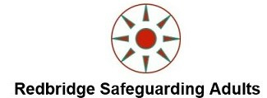

Name of person at risk:

Dependents/other residents: Consider Coercive and Controlling behaviour

LAS Reference: |  |  |  |  | NHS Number:
Date of Birth: |  |  |  |  | Ethnicity:
Address: |  |  |  |  | Postcode:
 | Reason for referral:
 | Consent: (Has consent been obtained & recorded Is the Adult who is at risk of self-neglect aware of the concern will be reported to appropriate agencies)
 | YES/NO (circle) |  | If yes, the Best Interest assessment can only be undertaken if the person lacks capacity to make a particular decision
 | If consent has not been obtained (consider is a Mental Capacity Assessment required)
 | YES/NO (circle) |  | If no, an assessment must be completed before a Best Interests decision is undertaken
 | Detail of decision to be made

Risk(s) identified: (tick box (es) as appropriate) | Additional comments
NRPF/ Immigration status

Homelessness

Alcohol, drugs and/or gambling harm (s)

Clutter/Hoarding

Mental health

Physical health

Any other risks identified (not included above)

Name of Lead Agency

Details of agencies involved: Name, Job Title, Relationship, Lead agency/organisation, contact number
Name/role |  | Job Title, Organisations, Relationship, contact number

Information about the person at risk(s): Consider How will the person be involved in this assessment? What support do they need to be involved? For example, does the person have mental capacity to make relevant decisions, do they need an advocate, friend or family member to facilitate their involvement?
Note: Please outline the circumstances of the person at risk and their support needs and support networks.
H

Why is this assessment needed?
What has happened to require this assessment? In some circumstances you may need to include a range of multi-agency views and information about agencies involvement and attempts to engage.
What is the person at risk views about the concerns?
In supporting the person to manage risks in their own life, you should always start with the adult at risk’s views, record these here. Reference to be made to capacity, fluctuating capacity and best interest decisions.
What changes does the person at risk want to achieve?
(Desired Outcomes)

Risk Assessment and Analysis
(Use this section to assess and analyse the risks. This will inform your risk management plan)

What is the level of the risks of harm? (risk matrix score) What is the evidence for this?
(risk of self-harm, clutter rating, lack of mental capacity, homeless with unmanaged physical & Mental health needs)
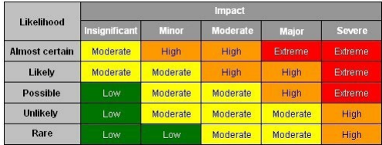 | 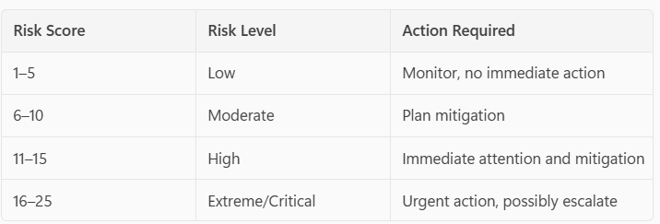 Score=Likelihood x Impact  Overall score: _________ High/medium/Low risk
What is the potential harm, and for whom?

What existing factors increase the risk of harm?
These sections ask you about the underlying issues. It is the understanding of these underlying issues that should be used to inform the development of a Risk Management Plan.
What factors decrease the risk of harm? Existing factors that currently reduce the risk(s)

Risk Management Plan

Risk Management Plan Actions
- Consider the factors identified that increase the risk of an incident occurring/recurring. Can any of these be reduced?
- Consider the factors identified that reduce the risk of an incident occurring/recurring. Can any of these be built upon?
- Remember, actions taken may be those of the person at risk, their friends/family, as well as practitioners or organisations.

Action Plan | Who will do this? | When will this be done?
1.
2.
3.
4.
5.
6.

What are the views of the person at risk (or their advocate) on these plans?
Does the person at risk feel safer?
What is the revised risk Score (with mitigating actions in place)
Risk Score=Likelihood x Impact
Overall score: _________ High/medium/Low risk

Risk Management Plan Comments: Use this section as required. You may wish to comment on areas of disagreement or options considered that were declined by the person at risk or views on the impact/benefits of this plan for the person at risk. For example, will the plan help the person to achieve their desired outcomes?

Contingency Plan If, despite the risk management plan being in place, an incident occurs – record here how people should respond. | Person  responsible

Views of relevant professionals/agencies on the plan, including relatives (where appropriate)
Name:  Signature: | Date:

Arrangements for review:
How will the risk assessment/management plan be reviewed?
Note: If a review meeting is not required, please explain how risks will be monitored in the future
Date of planned review:

Completion information:
Date completed:
Assessment completed by:
Signature:
Team Manager:
Signature:
Senior Manager / Service Delivery Manager:
Signature:

All information recorded is strictly confidential. It should not be used for any purpose other than the safeguarding or care and support of the person concerned. If any individual or organisation wishes to use information given at this meeting for any other purposes, they must seek the explicit consent of the organisation or person that shared it.

